## The Roundabout Tool

The Roundabout tool is relatively simple to use and blends easily like other road tools.

**To Create a Roundabout:**

* Select the **Roundabout** tool in the Roads tab of the Tools palette
* Click once to place the roundabout, this is going to be a center of your roundabout
* Shift your mouse up or down to make the roundabout bigger or smaller
* Right click to finish
* 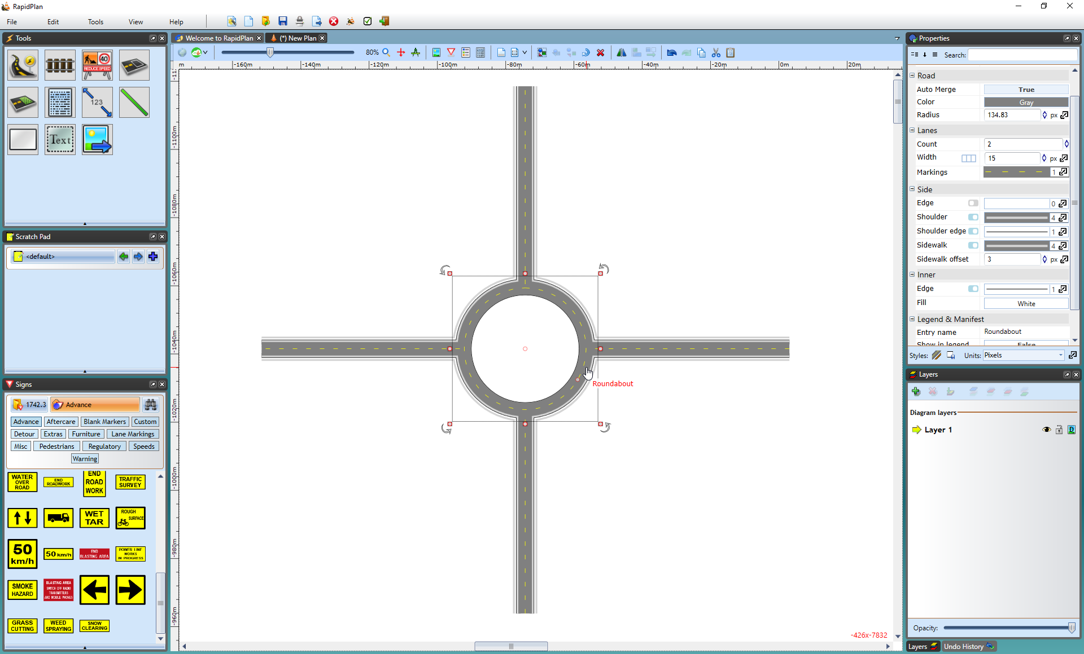
* Roundabout